READ ME FIRST

This DEHS dataset contain the enumeration from 311 enumeration area(EA) out of the planned 660 EA. The data obtained from this version contain 3063 HH out of 6600 planned HH (46%) of the sample, and total of sampled individual is 5523.
Geographical Location
To obtain geographical information of the household s, please refers to “BUKU1COV.dta” , there you will find geo location from province until desa. Additional geograpgical information in form of island and urban agglomeration definition could be found on the following variables: island, metroname_new, coreperiphery_new ,singlemultiplemetro_new.

Wealth Estimate
Due to lacking consumption module, the DEHS data is equipped with 2 deciles estimate which could be found on “deciles.dta”. Two estimate of welfare deciles is created using PMT approach and asset index approach. A test using Susenas March 2019 data of these approaches created a total correctly classified deciles that almost the same between two approaches (but with different precision across deciles between the approaches). One note that also note to be taken, is that the weighted asset index decile is less smooth at the top 30% of the distribution (please figure 1, below), which create unequal split of household at the top

Figure1. deciles comparison between PMT and Asset Index approach
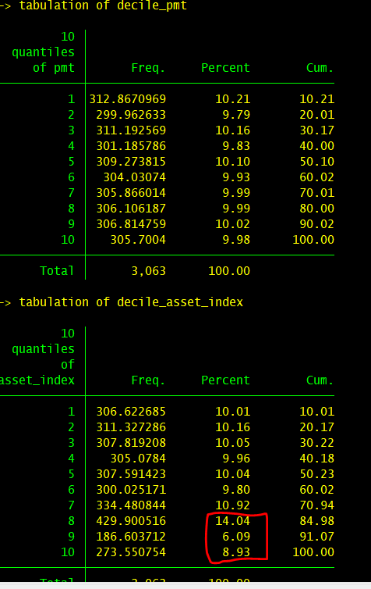

Weight and representativeness
To create a population representative statistics, an inverse probability weight (frequency weight) has been devised and could be found at ”dehs_final_weight.dta” under the name of “wgt”. The weight is unique at wilcah(enumeration area) level so merging of the weight should be conducted using the wilcah variable. As the weight contains fraction please use “aw” option rather than “fw” option when calulating your statistics using tab command, and use “iw” instead of “fw” when using tabstat command. The weight will be able to provide you with representative statistic at national and urban rural dissagregation. Beside the weight we also provide you with the sampling information that could be found in “strata1” “su1” “fpc1” “su2” “fpc2”. These variables could be use to calculate the correct standard error (if you need one) or to calculate cv or rse. I would suggest you to use svy command and use these extra information if you conduct regression analysis. Lastly. Please be aware of rare cases statistics, while the weight will provide representative stat at national and urban rural for most of our indicators it wont be the case of rare statistics. As rule of thumb a rare statistic mainly occur if you create a statistics from less than 5% of the nationally representative data. But to be precise you could always use the relative standard error or cv. If you stats results 20-25% RSE, you should doubt the representativeness of the statistic that you’ve produced .

For instance, what is the proportion , standard error, and cv for population by gender in our data
use "BUKU1_AV.dta", clear
merge m:1 wilcah using "dehs_final_weight"
svyset su1 [pweight=wgt], strata(strata1) fpc(fpc1) vce(linearized) singleunit(centered) || su2, fpc(fpc2)

*proportion by gender
svy: prop av_4
estat cv

Merging datasets
So as in another data such as the Susenas, individual ID is given in form of:
“unique household id” and “id (number) of the individual in the roster” (please see the questionnaire in book 1 ), I see both of these variables existed in the datasets that collected information from individual respondents. So please use these 2 variables as individual ID

DO NOT USE cspro_id, as it is just id in the cspro program, and thus it is not labeled on the stata data. Please see the screenshoot below, merging using cspro_id resulted in 0 match between books (ie; merging between HH information on book 1 and individual internet access in book 2). But if you merge using household id you’ll find perfect match.

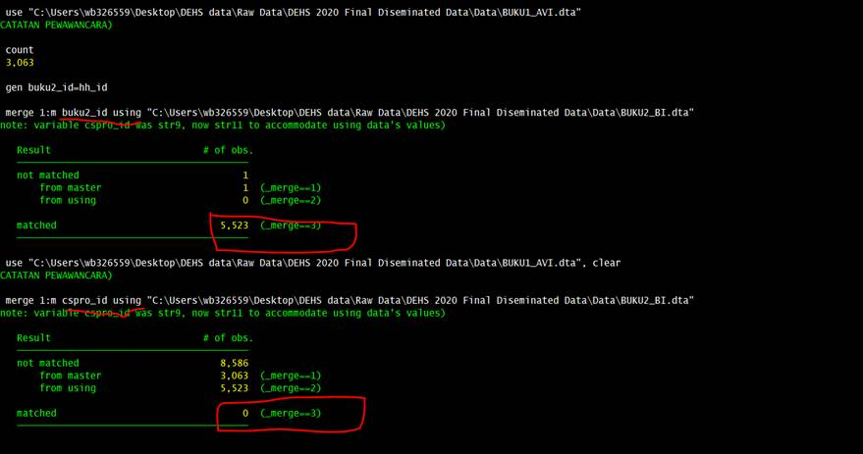

Also if you use household id and individual no in roster to merge between individual data, you’ll find perfect match

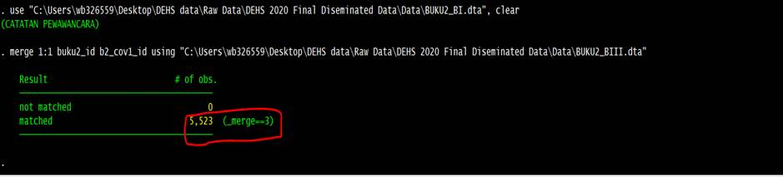

Just a kind reminder on how to merge

- Merging household data with household data, using household id as the merging variable
- Merging household data with individual data , using household id as the merging variable
- Merging individual data with household data , using household id as merging variable
- Merging individual data with individual data , using household id and individual number in the roster as merging variable

Ps: Survey Meter name the household id slightly differently across book, hh_id, buku2_id, buku3_id, buku5_id, buku6_id, buku9_id, but they are the same household ID (and labeled). So for analyst that want to merge across book for household data. Just rename these variables. Also please remember when opening data in the DEHS, please refer first to the questionnaire of the book, so you’ll remember what is the unit of the observation (HH, or indiv, or roster of things).

Number of observations in each data and codebook of your variable
To verify that you data should have the correct number of observation, please see the “cek_observasi_sm.xlsx”. if you find that the number of observation in your data is not the same with the figure on the excel file, please contact me, and I will contact Survey Meter for clarification. Also if you should need to see the value label of your data, please open the “codebook_dehs.zip”, and please let me or Mayla know if you have values that you wish to clarify.

